**Emotion Detection Project Documentation**

**Name : Naveen Kumar P**

**Team Number : 10**

**Contact :** [**naveenpalani75@gmail.com**](mailto:naveenpalani75@gmail.com) **+91 8248893625**

**Abstract**

The Emotion Detection Project focuses on developing a real-time system capable of recognizing and classifying human emotions from facial expressions using deep learning techniques. By employing convolutional neural networks (CNNs), the project aims to detect seven primary emotions: **Angry , Disgust , Fear , Happy , Sad , Surprise , and Neutral** . The culmination of this project is a functional model integrated with a live webcam feed, achieving an accuracy of **54.01%** . This document provides a comprehensive overview of the project's objectives, methodologies, results, and future directions.

**Mission**

To create an accessible and efficient emotion recognition system that leverages deep learning to interpret human facial expressions, thereby enhancing human-computer interaction and contributing to fields like psychology, security, and user experience design.

**Vision**

To pave the way for advanced emotion-aware technologies that can understand and respond to human emotions in real-time, fostering more intuitive and empathetic interactions between humans and machines, and promoting innovations that benefit societal well-being.

**Table of Contents**

* Dataset Preparation
* Data Preprocessing
* Model Architecture
* Training the Model
* Evaluating the Model
* Saving and Loading the Model
* Real-Time Emotion Detection with Webcam
* Results and Analysis
* Challenges and Limitations
* Future Improvements
* Conclusion
* References

**Introduction**

Understanding human emotions through facial expressions is a pivotal aspect of non-verbal communication. The Emotion Detection Project leverages advancements in deep learning to interpret facial cues and classify emotions in real-time. By integrating a CNN-based model with webcam capabilities, the project aspires to contribute to applications in areas such as mental health assessment, entertainment, security, and enhanced user experiences.

**Dataset Preparation**

**Dataset Overview**

The project utilizes a facial expression dataset containing thousands of images categorized into seven emotion classes:

- Angry

- Disgust

- Fear

- Happy

- Sad

- Surprise

- Neutral

**Directory Structure**

The dataset is organized into training and validation sets with the following structure:

Each directory contains images corresponding to the emotion label.

**Data Preprocessing**

**Image Augmentation**

To enhance the diversity of the training data and prevent overfitting, various image augmentation techniques are applied:

- Rescaling : Normalizing pixel values to the range [0, 1].

- Rotation : Random rotations up to 30 degrees.

- Shifts : Horizontal and vertical translations up to 20% of the image dimensions.

- Shear Transformation : Applying shear intensity transformations.

- Zoom : Random zoom within a specified range.

- Horizontal Flip : Randomly flipping images horizontally.

- Fill Mode : Filling in new pixels created after transformations.

**Data Generators**

Data generators read images from directories and apply augmentation in real-time during training.

**Model Architecture**

**Convolutional Neural Network (CNN)**

A sequential CNN model is constructed to learn hierarchical feature representations from facial images.

**Layers Description**

1. Input Layer : Accepts 48x48 grayscale images.

2. Convolutional Layers :

- Conv2D layers with increasing filters (32, 64, 128) and kernel size of (3,3), activated by ReLU.

3. MaxPooling Layers : Reduces spatial dimensions after each Conv2D layer.

4. Flatten Layer : Converts 2D feature maps to a 1D feature vector.

5. Dense Layers :

- Dense layer with 128 units and ReLU activation.

- Dropout layer with a rate of 0.5 to prevent overfitting.

- Output layer with 7 units (for each emotion class) and softmax activation.

**Model Summary**

**Training the Model**

**Training Parameters**

- Optimizer : Adam optimizer with a learning rate of 0.001.

- Loss Function : Categorical cross-entropy.

- Metrics : Accuracy.

- Epochs : 50.

- Batch Size : 32.

**Training Loop**

**Evaluating the Model**

**Accuracy and Loss Curves**

Plotting training and validation accuracy and loss over epochs provides insights into the model's learning progress.

**Confusion Matrix and Classification Report**

Evaluating the performance using a confusion matrix and classification report for detailed analysis.

**Saving and Loading the Model**

Saving the Trained Model

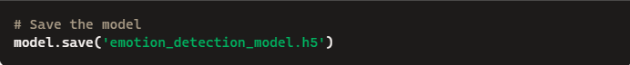

**Loading the Model**

**Real-Time Emotion Detection with Webcam**

Overview

Implementing a real-time emotion detection system using the computer's webcam to capture live video, detect faces, and predict emotions on the detected faces.

Implementation Using Tkinter GUI

```python

import cv2

import numpy as np

import tensorflow as tf

from tkinter import Tk, Label, Button

from PIL import Image, ImageTk

Load the trained emotion detection model

model = tf.keras.models.load_model('emotion_detection_model.h5')

Load Haar Cascade for face detection

face_cascade = cv2.CascadeClassifier(cv2.data.haarcascades + 'haarcascade_frontalface_default.xml')

Labels for emotion classes

class_names = ['Angry', 'Disgust', 'Fear', 'Happy', 'Sad', 'Surprise', 'Neutral']

Initialize Tkinter GUI

root = Tk()

root.title("Emotion Detection")

Create a label to display the camera feed

label_widget = Label(root)

label_widget.pack()

Function to detect emotions

def detect_emotion(frame):

gray = cv2.cvtColor(frame, cv2.COLOR_BGR2GRAY)

faces = face_cascade.detectMultiScale(

gray, scaleFactor=1.1, minNeighbors=5, minSize=(60, 60)

)

for (x, y, w, h) in faces:

Extract the region of interest (ROI) corresponding to the face

roi_gray = gray[y:y + h, x:x + w]

Resize the ROI to match the model's expected input size (48x48)

resized = cv2.resize(roi_gray, (48, 48))

normalized = resized / 255.0 Normalize the image

reshaped = np.reshape(normalized, (1, 48, 48, 1))

Predict the emotion

prediction = model.predict(reshaped)

max_index = int(np.argmax(prediction))

emotion = class_names[max_index]

color = (255, 0, 0) Color for the rectangle and text

Draw bounding box and label

cv2.rectangle(frame, (x, y), (x + w, y + h), color, 2)

cv2.putText(

frame, emotion, (x, y - 10), cv2.FONT_HERSHEY_SIMPLEX,

0.9, color, 2

)

return frame

Function to update the camera feed in the GUI

def update_camera():

ret, frame = cap.read()

if ret:

Detect emotions

frame = detect_emotion(frame)

Convert the frame to RGB format

frame_rgb = cv2.cvtColor(frame, cv2.COLOR_BGR2RGB)

img = Image.fromarray(frame_rgb)

imgtk = ImageTk.PhotoImage(image=img)

Update the label with the new frame

label_widget.imgtk = imgtk

label_widget.configure(image=imgtk)

Repeat the function after 10 milliseconds

label_widget.after(10, update_camera)

Function to start the camera feed

def start_camera():

global cap

cap = cv2.VideoCapture(0) Use 0 for default camera

update_camera()

Function to stop the camera feed

def stop_camera():

if 'cap' in globals():

if cap.isOpened():

cap.release()

root.destroy()

Add buttons to start and stop the camera

start_button = Button(root, text="Start Camera", command=start_camera)

start_button.pack()

stop_button = Button(root, text="Stop Camera", command=stop_camera)

stop_button.pack()

Start the Tkinter main loop

root.mainloop()

```

---

**Results and Analysis**

**Final Model Accuracy**

- **Validation Accuracy : 54.01%**

- The model demonstrates a foundational ability to recognize emotions from facial expressions.

**Observations**

- Strong Performance : The model performs relatively well on emotions with distinct facial features like Happy and Surprise .

- Confusion Among Classes : There is notable confusion between emotions such as Fear and Sad , indicating the need for more nuanced feature extraction.

- Real-Time Detection : The integrated system successfully detects faces and predicts emotions in a live webcam feed.

**Challenges and Limitations**

**Dataset Imbalance**

- Description : Uneven distribution of images across emotion classes.

- Impact : The model may bias towards classes with more samples.

Subtle Emotional Differences

- Description : Difficulty in distinguishing emotions with similar facial expressions.

- Impact : Lower accuracy for certain emotion classes.

**Environmental Factors**

- Lighting Conditions : Variations in lighting can affect face detection and recognition.

- Occlusions : Accessories like glasses or masks may hinder accurate detection.

Computational Constraints

- Real-Time Processing : Requires efficient computation to maintain live detection without lag.

---

**Future Improvements**

**Enhancing the Dataset**

- Data Augmentation : Implementing advanced augmentation techniques to simulate real-world variations.

- Collecting More Data : Gathering additional images, especially for underrepresented classes.

**Model Optimization**

- Architecture Exploration : Testing more complex models like ResNet, VGG, or using transfer learning.

- Hyperparameter Tuning : Adjusting learning rates, batch sizes, and epochs for better performance.

Real-Time Performance

- Model Compression : Utilizing techniques like quantization or pruning to speed up inference.

- Hardware Acceleration : Running the model on GPUs or specialized hardware.

**Improving Face Detection**

- Advanced Detectors : Using more robust face detection algorithms to handle occlusions and varying conditions.

**Multimodal Emotion Recognition**

- Additional Inputs : Incorporating voice tone analysis or physiological signals.

**Conclusion**

The Emotion Detection Project represents a significant step toward creating machines that can interpret human emotions through facial expressions. While achieving a validation accuracy of 54.01%, the project underscores both the potential and challenges of emotion recognition systems. Continuous improvements in data quality, model architecture, and real-time processing capabilities are essential for advancing this field.

The integration of the model with a live webcam feed demonstrates practical applicability, setting a foundation for future developments in human-computer interaction and emotion-aware applications.

**References**

1. Datasets

- FER-2013 Dataset

- CK+ Dataset

2. Libraries and Tools

- TensorFlow: [https://www.tensorflow.org/](https://www.tensorflow.org/)

- OpenCV: [https://opencv.org/](https://opencv.org/)

- Keras: [https://keras.io/](https://keras.io/)

- Matplotlib: [https://matplotlib.org/](https://matplotlib.org/)

- Seaborn: [https://seaborn.pydata.org/](https://seaborn.pydata.org/)

- Tkinter: Standard Python GUI library

3. Research Papers

- Li, S., Deng, W. "Deep Facial Expression Recognition: A Survey." IEEE Transactions on Affective Computing.

- Goodfellow, I. et al. "Challenges in Representation Learning: A report on three machine learning contests." Neural Networks.

**PROGRAMS**

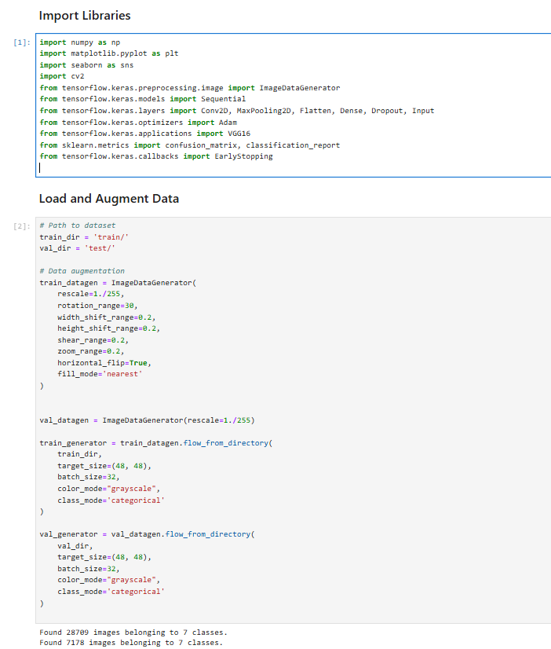

**RESULT**

